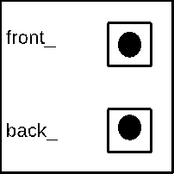Current Object



18







7



7



19



21



rhs





23



15



10



8

